Test Plan Document
INTERNATIONAL-KIDS.COM DEVELOPMENT PROJECT

Prepared by Netizen Team
Version 1.0
Created on : 10-Oct-2007
Last Modified :
Document: Test Plan

Revision History
Version / Revision Number | Author | Description | Approver | Effective Date
1.0 | Netizen | Initial Test Plan Draft

Table of Contents

1 Introduction 4
1.1 Purpose of this Document 4
1.2 Overview 4
1.3 Scope 4
1.3.1 Testing Phases 4
1.3.2 Testing Types 5
1.4 Not in Scope 6
1.5 Reference Documents 6
1.6 Definitions and Acronyms 6
1.7 Assumptions and Dependencies 7
1 Test Requirement 7
2.1 Features to be Tested 7
2.2 Milestones (Schedule) 10
2 Testing Environment 11
1.8 Browsers 11
1.9 Hardware and Software Requirements 12
1.10 Human Resources 18
3 Roles And Responsibilities 18
4 Test Strategy 20
Test Process Workflow 20
1.11 Test Organize/Review Project Documentation 21
1.12 Develop System Test Plan 21
1.13 Test Design/Development 22
1.14 Unit Test Execution 23
1.15 Integration/System Test Execution 23
1.15.1Integration Testing 23
1.15.2System Testing 24
5.6.3 Testing Types 24
5.6.4 Test Execution workflow 28
1.16 Defect Tracking and Management 32
1.17 Update Documents and Results 37
1.18 Test Reports 37
1.19 UAT and Closure 38
5 Configuration management 39
6 Deliverables 39

Introduction

Purpose of this Document

The purpose of this document is to outline the Test Strategy/Approach and the Quality Assurance process for the International-kids.com. This document will establish the System test plan for the International-kids.com application. It will allow the development team, business analysts, and project management to coordinate their efforts and efficiently manage the testing of the site. The QA process outlined in this System Test Plan will ensure that a quality International-kids.com application is deployed successfully and on schedule.
The intended audiences for this document are all stakeholders of the International-kids.com project.

Overview

The current International-kids.com is Windows XP based, compatible with Office2002 and written in PHP, using MYSQL 5.0 Server database. International-kids.com expectation with the new application is twofold:
- Front Office functionalities and
- Back Office functionalities
The focus is primarily on successful migration and implementation of the application.
The main objective of this Test plan is to define the methodology to test International-kids.com application to check and ensure that
- New system preserves all of its current business functionalities.
- The enhancements have been implemented to the new system.
- Newer enhancements do not adversely affect the current business functionalities.
- The system has flexibility /capacity to deal with complex International-kids.com structure and programs, as it continues to change

Scope

1.3.1 Testing Phases
The following table lists the various phases of International-kids.com application testing and the team responsible for it.

Phases | Teams Responsible
Unit Testing | Development team
Integration Testing | Testing team
System Testing | Testing team
User Acceptance Testing | International-kids.com User Representatives

1.3.2 Testing Types

International-kids.com application will undergo the following types of testing. All types of testing are explained in detail under Test Strategy section

Activity | Teams Responsible
Functionality Testing | Performed by testing team during Integration/System testing phase to meet agreed upon functional requirements of International-kids.com application.  Following Functional areas will be put to test: (1) Application Submission (2) Peer Review. All the features put under test are mentioned in brief under “Features to be tested” section in this plan.  All the features put under test will be described in detail in Test Scenario documents and Test case documents. On completion of every single functional area, test scenario and test case documents will be delivered. Please refer to Deliverables section mentioned below.
Database Testing | Performed by testing team during Integration/System testing phase to qualify database which houses the content that the International-kids.com application manages, run queries and fulfill user requests for data storage  Database migration testing will be taken care by DBA’s
Security Testing | Performed by testing team during Integration/System testing phase to meet agreed upon Security requirements of International-kids.com application
GUI and Usability Testing | Performed by testing team during Integration/System testing phase
Performance and  Load /Volume Testing | Performed by testing team during System Testing phase.  Automation testing will be performed to carry out these types of testing.  <Tool name to be decided/updated> tool will be used to perform these tests.  Various Reports that are part of International-kids.com Application will be one of the main areas while performing load/volume testing  Performance test methodology.
Code Testing | Performed by development team during Unit Testing phase at every method level.
Smoke Testing | Performed by development team during Unit Testing phase for qualifying the build for releasing it to Testing team.  Performed by Testing team during Integration/System phase for qualifying the build for further tests.
Regression Testing | Performed by testing team during Integration/System testing phase for re-testing an entire or partial system after a modification has been made to ensure that no unwanted changes were introduced to the system.
Defect fix verification testing/Defect validation testing) | Performed by testing team during Integration/System testing phase for verifying the defect fixes
Compatibility Testing | Performed by testing team during Integration/System testing phase to test the compatibility with respect to base configuration  - Browser (IE 6.0), O.S. (Win XP)  - Mozilla fire fox( ), O.S (Win XP)  - Opera ( ), O.S (Win XP)  Certification testing will be performed on following combinations :  Browser (IE 7.0), O.S (Win XP)
Interface Testing  - Sign on | Performed by Development team during Unit testing phase  Performed by testing team during Integration/System testing phase and  Performed by International-kids.com team during UAT phase in order to have a complete test.  PA testing team will be responsible for testing this functionality by accessing International-Kids.com -QA environment
Adhoc Testing | Performed by Testing team during Integration/System testing phase to test the (1) Navigations that are unusual and (2) Negative scenarios within and across the components.

Not in Scope
- Stress Testing
- Crash/Recovery Testing
- When the scope of the new application has been agreed and signed off, no further inclusions will be considered for inclusion in this release, except:
- Where there is the express permission and agreement of the Business Analyst, Project Manager and the Client;
- Where the changes/inclusions will not require significant effort on behalf of the test team (i.e. requiring extra preparation - new test conditions etc.) and will not adversely affect the test schedule.

Reference Documents
# | Reference Document Name
1. | International-Kids.com Software Requirements Document
2. | International-Kids.com Test plan

Definitions and Acronyms
Acronym | Description
QA | Quality Assurance
SRD | Software Requirement Document
PM | Project Manager
PL | Project Lead
TL | Technical Lead
International-Kids.com | International-Kids.com

Assumptions and Dependencies
- Build will be released on time for testing as per the plan.
- All “Show-Stopper” bugs receive immediate attention from the development team.
- Testing of all available features in International-Kids.com application will be done using data dump provided by DBA.
- Enhancements will be incorporated into the original design of the International-Kids.com application.
- Some enhancements will require further analysis. This analysis will be worked out during construction phase.
- All bugs that are prioritized for next version will be unit tested and fixed by the development team before the next version can be released.
- Functionality of the system will be delivered as per schedule and specifications for the testing team during each phase
- Required resources will be available. Project Manager will ensure availability of environment.
- Once the PA code enters DBA’s development environment, all bugs will be tracked using Bugzilla which is DBA’s Bug tracking tool. All bugs will be tracked under RIS project in Bugzilla.

Test Requirement

2.1 Features to be Tested

1. General requirements | - General requirements for Landing pages of various Roles/Users (International-Kids.com landing page requirements)  - Dashboard functionality
2. Roles | - Functionality/ Role of each User in particular
3. Site entry/exit | - External/Internal user (Login/Logout)
4.Application Submission | - Registration (Update/view profile page)  - Applicant level validation  - Update/View/Re-submit  - Acceptance / Rejection of Application by Moderator.  - Approval of Application by International-Kids.com -Admin Staff
5. Peer Review | - Assignment to Committees  - Identification of Primary and Secondary Conflicts  - Assignment to Reviewers  - Dual Application  - Brokering list  - Reviewer/s  - Access to submitted applications  - Preferences  - Add/update Preliminary Scoring/Triage/Critiques/Concerns  - Meeting  - Critique Editing by (Reviewers and Admin)  - Concern Generation/Resolution  - Generation of Committee Scores/Final Scores/Median/Variance  - Average Merit & Percentile Score generation
6. General Administration | - NEW/Existing users Maintenance/Management  - Access control/Roles and Responsibilities(Security maintenance)
7. Email Functions | ( Initial Notifications, , Maintain Message Text)

All the features to be tested will be detailed in respective Test Scenario documents and Test case documents based on test types mentioned in Scope section.
All the Test Scenario documents will be delivered for review during Pre-construction phase and the Test case documents will be delivered in the middle of Construction phase just before integration test begins. Please refer to “Deliverables” section below for deliverable dates.

Milestones (Schedule)
NOTE: Following dates are projected with the assumption of beginning the Construction phase on 10th Oct 2007. Actual dates will be modified as per the Project plan once the construction phase begins.

Task Name | Duration | Start Date | End Date
Ramp up
Understand requirements and review docs.
Test Plan Development |  | 10-Oct-2006
Test Plan Review/Updation |  | 21-Oct-2006
Sign off on Test plan
Test Scenario Development
FunctionalArea1: Application Submission |  | 11-Oct-2007
Review and updation |  | 12-Oct-2007
FunctionalArea2: Peer Review |  | 15-Oct-2007
Review and updation |  | 16-Oct-2007
Non functionality requirements (Performance, Security, e.t.c) |  | 17-Oct-2007
Review and updation |  | 18-Oct-2007
Test Case Development
FunctionalArea1: Application Submission |  | 11-Oct-2007
Review and updation |  | 12-Oct-2007
FunctionalArea2: Peer Review |  | 15-Oct-2007
Review and updation |  | 16-Oct-2007
Non functionality requirements (Performance, Security, e.t.c) |  | 17-Oct-2007
Review and Updation |  | 18-Oct-2007
Establish Testing Environment |  | 19-Oct-2007
Smoke Testing |  | 22-Oct-2007
Functionality Testing  (Includes Functionality, Gui, Usability, Security and Database testing) |  | 23/24/25-Oct-2007
Regression Testing  (Includes Regression, Adhoc and Defect fix verification testing) |  | 26-Oct-2007
Integration Testing  (Includes External Interfaces and Module Interfaces testing) |  | 27/29-Oct-2007
Access to International-Kids.com QA Environment
System Testing  (Includes all types of testing mentioned above and the test types mentioned below) |  | 30,31-Oct-2007, 1-Nov-2007
Compatibility Testing
Performance and Load/Volume Testing
User Acceptance Testing

Testing Environment

Browsers

Browser | Execution | Environment
Internet Explorer 6.0 | √ | Win XP
Internet Explorer 7.0 | Certification | Win XP
Mozilla Fire Fox | Certification | Win XP
Opera | Certification | Win XP

Execution of Test cases:

“√” Symbol mentioned above refers to - “Entire test cases will be executed”.
The text , “Certification” mentioned above refers to - “Selected test cases will be executed to verify the capability of the application on these browsers”.

Hardware and Software Requirements

3.2.1 Offshore

This section describes the environment setup offshore that is used in the development and testing of the application.

Development/ Development Integration Environment:

The Development Environment offshore corresponds to the environment used by the developers during the construction. Unit Testing on International-kids.com version is performed on this environment. Each developer machine will have International-kids.com running on Apache Web server. There will be a common MYSQL development database server and all the developers will be using the same database server.

SOFTWARE
Type | Name | Version | OS
Web Server | Apache | Apache2.0 | Windows XP
Front End Designing Tool | PHP(Personal Home Page to Hypertext Preprocessor) | PHP 4.0/5.0 | Windows XP
Scripting Language | Java script and Ajax | Java Script  Ajax | Windows XP
Database | MYSQL | MYSQL 5.0 | Windows 2000 Server  Windows 2000 Professional
Browser | IE | 6.0 | Windows XP

HARDWARE
Machine type | HDD | RAM | CPU
Web server | 40 GB | 1 GB | Intel Pentium 4, 2.66GHz
Database Server(MYSQL) | 80 GB | 1 GB | Intel Pentium 4, 2.8 GHz

QA

The QA Environment offshore corresponds to the environment on which Integration Testing is performed for International-kids.com version.

Offshore QA

SOFTWARE
Type | Name | Version | OS
Web server | Apache | Apache 2.0 | Windows XP
Scripting Language | Java Script, Ajax | Java script  Ajax | Windows XP
Database | MYSQL | MYSQL5.0 | Windows 2000 Server
Browser (Base) | IE | 6.0 | Windows XP
Browser (Certification) | IE  Mozilla Fire Fox  Opera | 7.0  6.0/7.0  4.0/5.0  9.22 | Windows XP  Windows XP  Windows XP  Windows XP

HARDWARE
Machine Type | HDD | RAM | CPU | OS | Browser
QA web server | 40 GB | 1 GB | Intel Pentium 4, 2.8 GHz | Windows XP Professional
QA Database Server(MYSQL) | 280 GB | 1 GB | Intel Pentium 4, 2.8 GHz | Windows 2000 Server
Test 1 (Desktop class) /  Base | 40 GB | 1 GB | Intel Pentium 4, 2.4 GHz | Windows XP Professional | IE6.0
Test 2 (Desktop class) / Certification | 80 GB | 1 GB | Intel Pentium 4, 2.4 GHz | Windows XP Professional | IE 7.0
Bugzilla Server | 40 GB | 1 GB | Intel Pentium 4, 2.66 GHz | Windows XP Professional

Human Resources

Resource Title | Number | Date Required | Resource name
QA lead | 1
Test Engineer  (For performing Testing of types- Functionality, Gui/Usability, Database, Smoke, Regression) | 2
Test Engineer  (For performing Testing of types- Performance, Load/Volume, Compatibility, Security, Adhoc) | 1

Roles And Responsibilities

Role | Responsibility | Work Ph, Mobile, Email id | Name | Secondary Role
QA lead  (Team member) | - Preparing/Updating the Test plan  - Preparing/Updating the Test Scenarios  - Reviewing the Test cases  - Building/deploying the application in QA/System integration environment  - Preparation of Traceability matrix  - Daily Test plan preparation***  (Please refer below for details)  - Generating Test summery report |  |  | Project Lead / Project Manager
Tester 1/2/3  (Team member) | - Preparing/updating Test cases  - Reviewing the test cases  - Executing test cases in Integration / System environment  - Recording test results in Integration/System environment  - Impact analysis for failed test cases  - Logging/verifying/closing and tracking defects  - Raising issues/clarifications in Issue tracker/clarification register on Bugzilla.  - Perform various types of testing like Functionality, Smoke, Regression, Adhoc, Security, GUI/Usability, Volume, Compatibility, Performance/Load, Database. |  |  | QA lead

Daily Test plan preparation***

The QA lead is responsible for preparing the daily test plan that shall include the following:

  - Allocate the workload for each tester
  - Plan to ensure that the tests being performed will cover all required functionality for the required OS and Browser.
  - Create and maintain a list that defines the range of scripts/test cases to be completed on specific days
  - Distribute/communicate this list to the testers
  - Distribute the Daily test plan to the Project Manager

Test Strategy

The Test Strategy presents the recommended approach to the testing of the International-kids.com Development Project. The previous section on Test Requirements described what would be tested; this describes how it will be tested.

Test Process Workflow

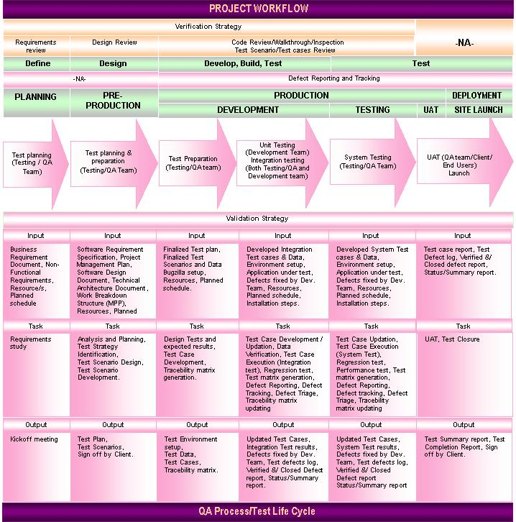
The above diagram explains the complete QA process/Test life Cycle in General. Following are the steps which would explain in detail , the Test Strategy to be followed for International-kids.com Application.

Step1. Test Organize/Review Project Documentation
Step2. Test plan
Step3. Test Design/Development
Step4. Unit Test Execution
Step5. Integration/System Test Execution
Step6. Defect Tracking and Management
Step7. Update Documents and Results
Step8. Test Reports
Step9. UAT and Closure

Test Organize/Review Project Documentation

Documentation reviews provide a means for testing the accuracy and completeness of the planning, requirements and specifications. Throughout the project, periodic reviews will be held to assure the quality of project documentation. These reviews will:
- Ensure project plans have adequate time allocated for testing activities and determine limitations.
- Ensure that the Business Requirements, Information Site Flow, Use Cases, Business Rules, and Technical Design documents clearly articulate the functionality of the International-kids.com.

Develop System Test Plan

This step of the testing process involves creation of the System Test Plan (this document). This will serve as the guidepost for development of test cases and for integration of testing with other project activities.

- This plan describes at a high level the overall testing plan and strategy for the International-kids.com Application.
- Professional Access will follow this plan to develop test scenarios/cases and scripts that will be used for system testing.
- Test scenarios will be described in separate document(s).
- Test Cases will be described in separate document(s)
- Professional Access will obtain test accounts and Ids for Interface testing (see Scope).

Test Design/Development

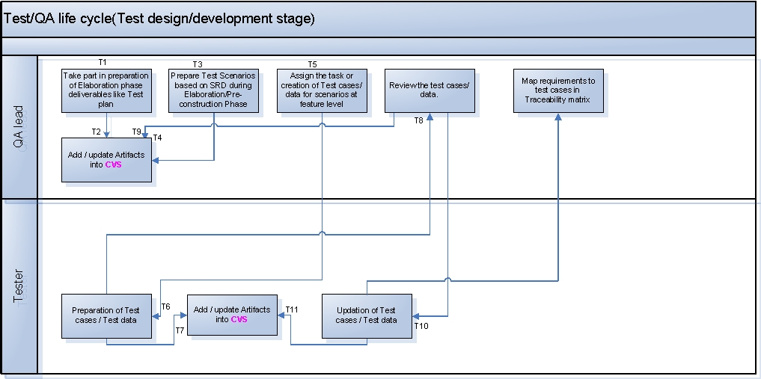

Brief explanation of Test Design/Development workflow with respect to the Process flow diagram displayed above:

T1,T2 | Test lead takes part in preparation of Elaboration phase deliverables like Test plan and updates the Artifacts in CVS for further reference
T3, T4 | From Post elaboration phase to Pre-construction phase, Test Scenarios would be designed by the Test lead for the modules/features available in SRD. When once final draft version of SRD with all modules/features specification/s is/are received, Test scenarios are designed and completed during Pre-construction phase. All the created/updated Test scenarios are hoarded in CVS
T5 | Test lead assigns the task of test case/test script creation to test team members during the Construction phase
T6, T7 | For all the Test scenarios created earlier during Post-elaboration/Pre-construction phase, the Test team members design test cases during Construction Phase. All the created Test cases/Test scripts are hoarded in CVS
T8, T9 | All the created Test cases/Test Scripts are reviewed by Test lead and all the review comments are updated in CVS
T10 | Test team members will check the review comments and update respective test cases and hoard the same in CVS.
T11 | Test Lead will map the requirements to Test cases in Traceability matrix (The objective of this matrix is to illustrate how to document which test case/s test which functionality of software and which structural attribute. It maps test requirements to the test cases/Test Scenarios that implement them.)

Written test cases and scripts will be used to direct system testing efforts. Professional Access test team will write these in accordance with the System Test Plan.

- Tests will be developed to exercise the required functionality for the website, validate data integrity, and ensure that data is passed or received successfully from external interfaces. Test Cases will be written in a separate document appended to this plan.
- Each test case will document the steps or actions required to exercise a specified area of functionality. The test cases will be reviewed to verify that they properly validate the intended functionality. Actual testing will be performed by executing the steps of the test case. A pass/fail notation will be made for each step.

- Each test case will be executed manually and using automated testing tool(for Performance/Load testing) using the browser versions mentioned in Test environment section. A pass/fail notation will be recorded for each condition tested, noting the severity and reason for each instance of failure. Test scripts to perform Performance/Load testing will be executed automatically during the System testing phase.

Unit Test Execution

Unit testing verifies each module, component, object, or program developed is functionally correct and conforms to requirements. A unit is defined as a single program function in terms of inputs, processes and outputs. A program unit is small enough that the developer who developed it can test it in great detail.

The developer that wrote the code is responsible for creating, updating and executing the unit tests after each successful build in the development environment. Separate document has been prepared drafting Unit test strategy.

Integration/System Test Execution

Integration Testing

The objective of these tests is to ensure that all the components of the system function properly together and that the application interfaces properly with external applications.

Entrance Criteria

- All functions to be tested have successfully passed unit testing
- All Severity 1 and 2 defects are fixed and have successfully passed unit testing. (See Defect Management portion of this document for severity definitions)
- Software build is properly version controlled
- Build report has been completed and submitted with build
- All hardware and software configurations are in place and ready to test
- All test cases required for integration testing have been prepared
- All required integrated systems are available

Exit Criteria

- All components delivered and tested function as detailed in the documents in the References portion of this document
- Test cases have been updated if and when functionality has changed
- Test results report is developed/updated
- All new defects have been logged into the issues tracking database

System Testing

The test team will conduct a system test to verify that the software matches the defined requirements. Once the application has executed successfully under integration test, each test suite will be executed against the other supported configurations to ensure defects are not created because the system configuration has changed. A separate test environment must be established for all hardware, software, and browser configurations supported

Entrance Criteria

- All functions tested have successfully passed integration testing
- All severity 1 and 2 defects are fixed and have successfully passed regression testing
- Test cases have been updated if and when functionality has changed
- All test cases required for system testing have been prepared
- All hardware and software configurations are in place and ready to test
- All required integrated systems are available

Exit Criteria

- All Severity 1 and 2 defects are fixed and have successfully passed regression testing
- The risks associated with not correcting any outstanding Severity 3and 4 defects have been identified and signed off by the Project Manager, Technical Lead, QA Lead
- All components delivered and tested function as detailed in the documents in the References portion of this document
- Regression tests have been performed and executed successfully
- Test results report is developed/updated
- All new defects have been logged into the issues tracking database

5.6.3 Testing Types

The scope of the work is to conduct testing in the following areas:

  - Functionality
  - Database
  - Smoke
  - Security
  - User Interface/Usability
  - Compatibility
  - Performance/Load/Volume
  - Adhoc
  - Regression

- Functionality Testing

The objective of this test is to ensure that each element of the application meets the functional requirements of the business as outlined in the:
    - Software Requirement Document/Use cases.
    - Software Design Document.
    - Other Functional documents produced during the course of the project i.e. resolution to issues/change requests/clarifications/feedback.
Secondly, includes specific functional testing, which aims to test individual process and data flows. This stage will also include Validation Testing, which is intensive testing of the new front-end fields and screens.
Functionality testing will be performed on every build that is right from when Build series (2 weeks Test process cycle) commences till the final System-testing pass. In other words, Functionality testing will be performed by testing team just after the development of set of features as per the decision of Technical lead/Project manager, basically as part of integration testing. This process will be continued till the completion of System testing phase.

- Database Testing

Database would be tested under following perspectives:

- Testing the database Schema (Stored procedures, triggers, views e.t.c) after migration (done by MYSQL DBA developer)
- Testing the database which houses the content that the International-kids.com application manages, runs queries and fulfills user requests for data storage (done by Testing team)
Issues to test are:
- Data integrity errors (missing or wrong data in tables)
- Output errors (errors in writing, editing or reading/retrieving/querying operations in the tables)

Database testing will be performed along with functionality testing on every build, right from the First Build series (2 weeks test process cycle) till the final Build series.

- User Interface/Usability Testing

The usability testing will be accomplished by verifying the information in each window is accurate. Menus, icons and toolbar functionality will be tested as applicable to the navigation and results panes. Importance will be given to graphics, contents, data presentation, feedback and error messages, design approach, user interface controls, formatting, instructions e.t.c. Multi Window Overlapping will be tested because product supports opening of multiple documents.
GUI/Usability testing will be performed along with functionality testing on every build, right from the First Build series (2 weeks test process cycle) till the final Build series.

- Adhoc Testing

Adhoc Testing is done on every build right from first Build series till the last Build series. This is mostly experience based testing and carried out from the application usage perspective. Just based on knowledge of functionality/ies the test team member will perform this test. He/she need not refer to any Test case/Scenario/Plan. User concentrates on navigations that are unusual, negative or across the components.
During the second week of every Build series (2 week test process cycle) Adhoc testing will be performed. This test will be performed during Integration test phase as well as System test phase.

- Smoke Testing

During Integration testing, which is performed in parallel with development phase, every time before releasing the Build to QA team, Development team performs Smoke testing to check whether mentioned/planned set of features have been implemented without getting into details. When once the build is released to QA team, before accepting the Build for further testing process, Smoke testing is performed to check whether the application’s planned set of most crucial functionalities work, without bothering with finer details. It does mean that for a released build, availability of all the features as mentioned in Release notes will be tested.
When once the System passes smoke test, it would be subjected for further tests. Before commencing System testing too, QA team would perform smoke testing to check whether all functionalities are implemented into the System at high level.

- Compatibility testing

- Browsers:
Compatibility matrix where different brands and versions of browsers are tested to a certain number of components and settings, for example Applets, client side scripting, ActiveX controls, HTML specifications, Graphics or Browser settings, has/have been mentioned in Section 3.2
- Settings, Preferences:
Depending on settings and preferences of the client machine, web application may behave differently. Options such as screen resolution and color depth would be considered while testing.
- Printing:
Despite the paperless society the web was to introduce, printing is done more than ever. Testing would be performed to check whether the pages are printable with considerations on:
- Test and image alignment
- Colors of text, foreground and background
- Scalability to fit paper size, e.t.c
Selected set of Usability/GUI test cases will be executed as a part of Compatibility testing during System testing phase.

- Security testing

Security testis will determine how secure the new AHA-RSDP system is. The tests will verify that unauthorized user access to confidential data is prevented.
This type of testing would be performed to check
- That for each known user type the appropriate function / data are available and all transactions function as expected and run in prior Application Function tests
- Directory setup
- That without authorization, access permissions will not be provided to edit scripts on the server
- Time-out limit
- Bypassing login page by typing URL to a page inside directly in the browser, e.t.c

- Performance and Load/Volume testing
Performance testing verifies the application’s response time under maximum load conditions. The purpose of performance testing is to measure the application under load conditions. Subjecting the application system to expected peak loads before release can ensure software quality. Questions answered are:
      - Do applications and databases perform correctly under load?
      - What response time can be expected and will it meet requirements?
      - What operations negatively impact performance?

Performance testing procedures

The general approach for load testing is to set up a test website configuration and to run selected test scripts against it to measure performance. The configuration and test environment should mirror the production environment. Individual tests will be run to verify correct operation of the scripts. Then the scripts will be run again in several cycles. Each cycle will increase the number of concurrent users until the required system capacity has been successfully demonstrated.

The testing process is inherently iterative; since early tests may encounter bottlenecks or defects. The tests will need to be repeated after the system has been tuned or reconfigured or the defects have been corrected. In many cases, one bottleneck may obscure the presence of another. Thus, when problems have once been corrected, it is possible (even likely) to encounter others on subsequent trials.

The goal of performance testing is to be able to:
- Determine if the customer will experience unacceptable response time when the store website is under load.
- Determine if the web server, application server or database server will crash under load.
- Tune the application based on performance issues found.

Metrics that we will attempt to achieve include:

- The response time from the point when the web server receives a page request to the point when the web server serves the requested page is a metric used to test performance. This metric will be revisited once the pages have been built to determine an acceptable response time. There will be separate metrics for the search results pages vs. the other pages.
- concurrent users *
- active users**
* Concurrent users refers to users who are maintaining an active session with the site and may or may not be actively clicking on the site. (Please see Technical Specification for details)
** Active users refers to those users who are actually clicking on the site at any given time. (Please see Technical Specification for details)

Areas of the website that we recommend load testing include :
Site Area | Concurrent Action Tested | Load Area
Home Page | - Where multiple users access the home page | Page loading/performance
Registration | - Where multiple users Register using different usernames | Updating the database
 | - Where multiple registered users login | Accessing the database
Search/Browse | - Where multiple users Browse same category | Accessing the database
 | - Where multiple users Browse different categories | Accessing the database
 | - Where multiple users Search various keywords | Accessing the database
General site Navigation | - Where multiple users navigate general site functionality | Page loading/performance

- Regression testing

A Regression test will be performed subsequent to the release of each Build from second release on wards to ensure that -
- There is no impact on previously released software with the addition of new functionality, and
- To ensure that there is an increase in the functionality and stability of the software.
- There is no impact on previously released software with the resolution of defects.

5.6.4 Test Execution workflow

Test Method:

The following activities will be performed during the test process:
- The development team will verify through unit testing that each module, component, object, and program is functionally correct and conforms to the use case definitions document.

- The test team will conduct a functionality/integration test of the larger system to ensure that all the functionalities/components of the system function properly together and that the application interfaces properly with external application/s.

- The test team will conduct a system test to verify that the software matches the defined requirements. All the test cases/scripts executed during previous QA cycles will be re-executed to check the correctness of the system. Once the application has executed successfully under integration test, each test suite will be executed against the other supported configurations to ensure defects are not created because the system configuration has changed. A separate test environment must be established for all hardware, software, and browser configurations supported.

- The test team recommends that performance testing be done using performance tool. The purpose of load testing is to ensure stability of the application under simulated load conditions. Automated performance testing tools can simulate the load on the system being tested, eliminating the necessity of employing hundreds of users, huge volume of data, many transactions and obtaining the required equipment.

- The test team will conduct the tests by executing the test cases and scripts. Each test case will test a specific area of functionality. Test cases will be comprised of several test scripts that detail that functionality. The test cases will be reviewed to ensure that they cover the scenarios needed to adequately test the site and its functionality.

- Each test case will have an expected result and a pass/fail column. If the expected result is achieved a value of “Y” will be recorded in the actual results column. If the expected result is not achieved a value of “N” will be recorded in the actual results column, and the defect will be logged in the issue-tracking database. The actions that led to the failure and an assessment of its severity will also be noted in the issue-tracking database.

- The development team will fix defects based on the level of severity assigned by the test team. The defect information will be recorded in the issue-tracking database (Bugzilla), and the developers will be informed of each new issue via email. The severity levels to be used during the test are described in the Defect Management portion of this document.

- The test team will receive notification via email after each defect has been corrected and unit tested by the development team. The test team will retest the defect by re-executing the test case and script in which the defect was found. The regression test will verify that the altered code has not adversely impacted previously working functionality.

- The test team will track all the test cases and test scripts using a Traceability document.

- Included within the scope of the test is an external interface test, designed to verify that all components provided by third party providers interface and interact according to specifications.

- A Separate test environment will be established for all hardware, software and browser configurations supported. Refer to Hardware and software requirements section for more information.

Following diagram explains the flow of test types/phases followed for International-kids.com Application.

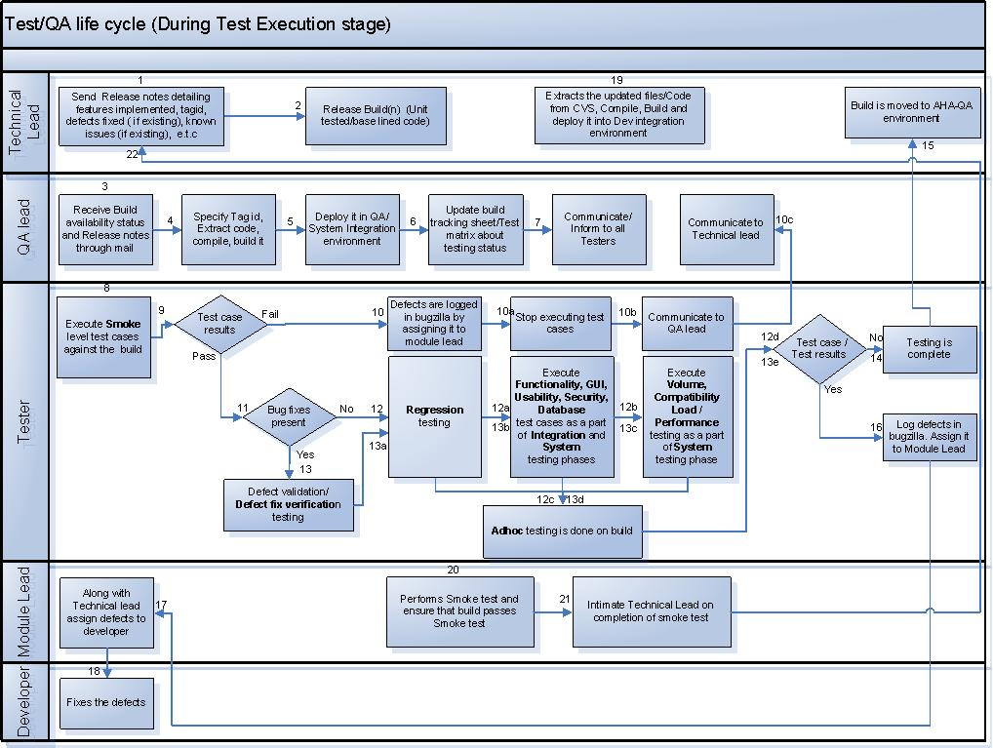
Test Flow:

Testing of International-kids.com application would be performed at feature level. A two week internal build release approach will be adopted while testing. Integration/Functionality Testing starts as soon as the first set of features is developed/released by the development team by adopting build series procedure. This process continues till the completion of System Testing. Development team will decide and inform testing team about the set of feature that are planned for every build release so that Test Scenarios/Test cases would be developed and reviewed well in advance

The typical flow of activities that happen in a 2-week QA test process cycle (Build Series) can be summarized through the Table given below.

Day | Series Phase | Activities
Monday | Start of Build Series N | - Build Series N: Test initialization activities  - Build Series N: Receive Build N and Release notes by 1 P.M  - Build Series N: Deploy the build  - Build Series N: Run Smoke test cases and Round 1 testing
Tuesday |  | - Build Series N: Round 1 Testing
Wednesday |  | - Build Series N: Round 1 Testing
Thursday |  | - Build Series N: Round 1 Testing
Friday |  | - Build Series N: End Round 1 Testing  - Build Series N+1: Features/Modules acquisition, planning, effort estimation, resource allocation
Saturday
Sunday
Monday |  | - Build Series N: Start Round 2 Testing
Tuesday |  | - Build Series N: Round 2 Testing
Wednesday |  | - Build Series N: Round 2 Testing  - Build Series N+1: Submit Test Scenarios/Cases for Review
Thursday |  | - Build Series N: Round 2 Testing
Friday | End of Build Series N | - Build series N: Test summery/conclusion report generation by the end of day  - Build Series N+1: Update test cases based on review feedback, prepare for series N+1
Assuming that the Test case/scripts Execution process begins from 15-Jan-2007(subjected to change) , QA team will execute the following testing cycles by considering

- Smoke Test pass
- Functionality test pass(which includes testing types like Functionality, GUI/Usability, Database and non-functionality test type like Security)
These are in turn divided into two categories based on builds
  - “1”- Execution of test cases of features included in current build
  - “2”- Re-Execution of test cases of features included in all the previous builds
- Integration test pass(which includes testing types like module interfaces and External interfaces)
- Regression test pass(which includes testing types like Regression, Adhoc and defect fix verification)
- System test pass( which includes all the above types of testing and testing types like Performance, Load/Volume, Compatibility )

QA Cycle  / Build Series | Duration | Smoke | Functionality |  | Integration |  | Regression | System | Test Cases/ Scenarios Updation/ Addition
QA Cycle  / Build Series | Duration | Smoke | 1 | 2 | 1 | 2 | Regression | System | Test Cases/ Scenarios Updation/ Addition
1 | 2 weeks | ✓ | ✓ |  | ✓ |  |  |  | ✓
2 | 2 weeks | ✓ | ✓ |  | ✓ |  | ✓ |  | ✓
3 | 2 weeks | ✓ | ✓ | ✓ | ✓ | ✓ | ✓ | ✓
 | 1 week Buffer time
4 | 2 weeks | ✓ | ✓ |  | ✓ |  | ✓ |  | ✓
5 | 2 weeks | ✓ | ✓ |  | ✓ |  | ✓ |  | ✓
6 | 2 weeks | ✓ | ✓ |  | ✓ |  | ✓ |  | ✓
7 | 2 weeks | ✓ | ✓ | ✓ | ✓ | ✓ | ✓ | ✓
 | 1 week Buffer time
8 | 2 weeks | ✓ | ✓ |  | ✓ |  | ✓
9 | 2 weeks | ✓ | ✓ |  | ✓ |  | ✓
10 | 2 weeks | ✓ | ✓ | ✓ | ✓ | ✓ | ✓ | ✓
11 | 2 weeks | ✓ | ✓ | ✓ | ✓ | ✓ | ✓ | ✓

Defect Tracking and Management

The defect management process ensures maximum efficiency for defect recognition and resolution. The objectives of this process are:

- To maintain a defect tracking system to reliably monitor defects and fixes.
- To preserve a history of defects and their fixes.
- To ensure prompt and efficient identification and notification of defects.
- To provide timely fixes and deployment.

QA team will use Bugzilla (a defect tracking tool), which will allow PA developers and QA members to carry out a full test cycle: find, log, assign, fix, verify, resolve, and close.

The number of defects that surface during the QA testing period, including their potential impacts and complexity to implement, can be quite unpredictable. The PA Technical Lead / Project Manager will respond to defects in the minimum time possible, and assign fixes to a particular build. Careful review of the impact of an implemented fix will minimize reoccurrence and/or the introduction of new problems.
However, since testing alone cannot fully verify that software is complete and correct, PA takes a comprehensive validation approach. QA processes are integrated into all stages of the PA Development from the start of the engagement (e.g., large scale planning, unit testing, etc.).

Bugzilla defect tracking tool will be used for defect tracking and reporting purpose. It can be accessed via the web:
- URL =
- Project name = International-kids.com
- Each team member will be given a User ID and Password

Following are activities performed during Defect tracking process:

    - A Test engineer executes the test case/script and compares the actual result with the expected. He/She enters test results under results column in test case document across each test case by marking “Pass”/”Fail”.
    - When a test case fails, after result is updated in test case document, A defect is entered into Bugzilla and the corresponding defect reference number is mentioned in the test report (test case document used for testing).
    - Following information is entered for every defect in each defect report:
  - Bug number
  - Summery
  - Description
  - Steps to re-create the problem
  - Attachments if any
  - Configuration the problem was found in (Browser/Os/version)
  - Function/component/module the problem was found in
  - Severity of problem
  - Owner/Assigned to
  - URL
  - Status
  - Submit Date
  - Submitter/Reporter
  - Resolution

    - The defect is assigned to the QA lead, who will in turn monitor all the defects for completeness before submission to Development Tech Lead.
    - All defects will be checked for duplicate defects in Bugzilla before submission to Development Tech Lead.
    - Defects should be reproducible before being submitted to development Tech lead.
    - QA lead will monitor all defects that are in the escalation process. The defects will be classified, managed and escalated using a process agreed upon between AHA and Professional Access.
    - Tech lead along with module lead will review the defects. If a defect is valid defect, Tech lead will assign it to respective developer or else reject it by specifying the reason and re-assign it to respective reporter/submitter
    - Defects will be fixed based on severity. Those defects entered as a Severity 1 (Critical/Showstopper), or Severity 2 (High) must be corrected prior to the application being deployed. Severity 3 defects (Medium) will be corrected based on consensus agreement between Project Manager, Technical Lead and QA Test Lead regarding their criticality.
    - The person, who has been assigned the defect, carries out the impact analysis (identifies the cause of the problem, identifies the impacted components and also identifies the fix to be carried out) and then fixes the defect appropriately. He records the impact analysis briefly in the Bugzilla.
    - Integration/System test cases are updated if the defect has been escaped due to the lack of corresponding Integration/System test case and Integration/System testing that was carried out by respective Submitter/Reporter.
    - Defects if any are captured and tracked for closure using the Bugzilla.
    - The Regression testing is performed by ideally re-running Integration/System tests of the changed programs. The modified components are re-baselined on successful conclusion of these tests.
    - The product is re-integrated, revised components are built and re-running of full system and integration testing is carried out.
Test cases are re-executed under following circumstances -
    - After a fix / a change / an enhancement.
    - Re-verify all functions of each build of application.
    - No new problem introduced by fix / change ("ripple effect").
    - During System Testing.

The diagram below provides an overview of the defect tracking process:

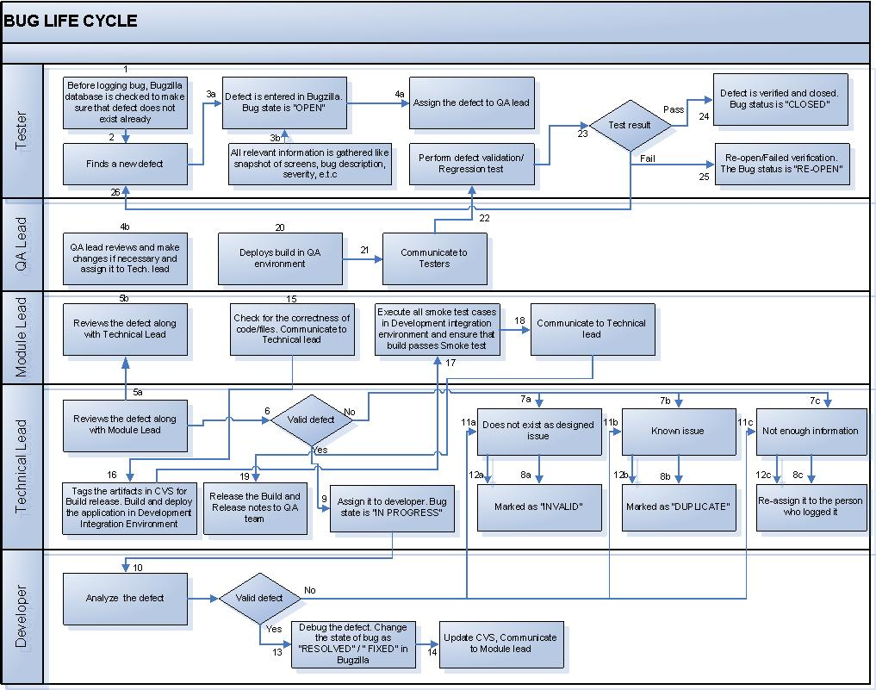

Defect Classification:

Defects identified by the PA testing team will be classified based on the guidelines explained in the subsequent sections. Apart from the guidelines, the context of a defect also has to be considered for proper classification of the defect. The defects can fall into one of the following categories:

Severity Level | Title | Description
1 | Critical/ Showstopper | - Causes global data corruption  - Missing functionality critical to site operation that was defined in specifications  - Critical function not operational (typically crash, severe application deficiency or malfunction); no work around exists  - A defect that would adversely impact the reputation of the client and is a critical business issue
2 | High/Major | - Component system hang or local data corruption.  - An Emergency defect that has been determined to have a work around.  - Non-critical function not operational; no work around. If a work around is determined to be available, then defect will be reclassified as Medium.  - Slow performance  - Examples: link broken but accessible via another click stream, garbled text in a paragraph, invalid data in a fields, unapproved content, and painfully slow downloads.
3 | Medium/Normal | - Non-critical function not operational; workaround is available  - Nonessential feature or function is missing or broken  - Operation is not user friendly or somewhat inconvenient  - Display typos or misalignments that do not affect system operation  - Bewildering dialog boxes or instructions  - Inaccurate spelling or grammar  - Functional or usage defect, which does not hamper the major usage of the application
4 | Low/Cosmetic/Minor | - Display typos or misalignments that do not affect system operation.  - An incorrect color on an element  - An incorrect object label  - Operation is somewhat inconvenient.  - This defect is not related to application functionality and mainly consists of aesthetic and usage issues

Priority:

Priority describes the importance and order in which a bug should be fixed. The available priorities are:

Priority level | Priority | Definition
P1 | High | Resolve the defect with immediate effect in very next release:  - Prevents further testing  - Full feature unavailable  - Client request  - Severe impact on client  - Effects other features
P2 | Medium | Resolve the defect at the earliest, before intermediate release (if any)
P3 | Low | Normal defect, Resolve before Final Client release
P4 | Very low | Could be fixed based on Triage  - Enhancements  - Necessity of the bug fix for the final Client release

Update Documents and Results

- Update the test scenarios, test cases and scripts if and when functionality workflow changes.
- Update the test case documents with results (Pass/Fail) , every time when test cases are executed
- Update the test case documents when there is no test case corresponding to the defect raised due to un usual flows if any.
- Update Traceability matrix every time when Scenarios/cases are updated or added.
- Develop the Test Results Report (Daily).
- Prepare and Review Conclusion Report.

Test Reports

Status Reporting

    - Bugzilla will be used to log bugs. Bug report should have sufficient information to reproduce the bug
    - QA testing will be reported to the Project manager on a daily/weekly by Producing Testing Results reports.
Test Results Reports should include, but is not restricted to the following:
Report name | Fields to include
Individual project status report | Name of tester  Types of testing performed  Number of test cases/scripts executed by him/her  Number of test cases/scripts not executed by him/her  Number of defects logged (valid, Invalid, duplicate)
Test case/script execution report | Number of features available for testing  Total number of test cases/scripts generated  Number of test cases/scripts executed per tester  Types of testing performed  Percentage of total test scripts completed
Defect status report | Total number of defects logged  Total number of defects verified/closed  Total number of open defects  Issues if any  Total number of Severity 1 Defects  Total number of Severity 2 Defects  Total number of Severity 3 Defects
Defects requiring escalation report | Components/functional areas affected  Date detected  Current Status

    - QA team and Project Manager will conduct daily/weekly bug scrub meeting. The following information will be discussed.
- Current status vs. planned (are we on schedule?).
- Test cases/scripts execution completed (can be at feature level).
- Number of defects open and their severity (Bugzilla).
- Summery of QA progress
- Issues that need clarification/action

Conclusion Report
Upon conclusion of the QA test cycle, the QA/Test Lead will document the results of the test phase of the International-kids.com system in the Conclusion Report. This report contains information such as:
- QA Test cycle number, duration and dates
- List of test cases executed
- Test team members
- Test case results
- Number of defects logged with status
- Metrics to quantify success of the project
- Copy of defect log

Test Summary Report

Test Summary Report would be a combination of all the above reports to present the final testing status during Intermediate/final Release.

UAT and Closure

International-kids.com to perform User Acceptance Testing for the migrated International-kids.com application will use the International-kids.com -UAT environment. The International-kids.com team will make this environment available either through their hosting provider or will host it internally. The purpose of these tests is to confirm that the system is developed according to the specified user requirements and is ready for operational use. The following are the anticipated tasks in making this environment available:
- Apache
- PHP,Ajax, Java Script
- MYSQL instance with data ready for testing
PA will coordinate with International-kids.com Deployment Specialist for the configuration on the environment and will provide International-kids.com code, consolidated migration scripts that are ready for installation into User Acceptance Environment and will perform resolution of defects from the User Acceptance Testing.

Testing will be deemed complete upon the execution of all of the following:

- All Functionality/Integration/System test cases.
- All outstanding issues are reviewed and accepted by the International-kids.com and PA Project Teams. These issues will include all major, critical, and blocker defects.
- Received signed-off creative and production components.
- The product is acceptable, which is based upon the following principles:
  - System testing is 100% complete and all fixed issues have been regressed and closed.
  - Calculation includes the total number of valid open bugs divided by the total number of bugs in the system. Total Open Bugs include bugs that are Unconfirmed, Assigned, New or Reopened, whereas Total Bugs include all bugs in the database with no exclusions.
  - All Major, Critical, and Blocker/showstopper bugs are closed.
  - 95% must be maintained upon the release of the project.

Configuration management

Please refer to the Configuration Management document that explains about the complete Configuration management workflow to be followed.

Deliverables

NOTE: Following dates are projected with the assumption of beginning the Construction phase on 11th Dec 2006. Actual dates will be modified as per the Project plan once the construction phase begins.

Deliverable name | Deliverable Date
Test plan | 10-Oct-2007
Test Scenarios
FunctionalArea1: Application Submission
FunctionalArea2: Peer Review
FunctionalArea3: Pre Awards
FunctionalArea4: Post Awards
FunctionalArea5: Reports and Admin
Non functionality requirements (Performance, Security, e.t.c)
Test cases
FunctionalArea1: Application Submission
FunctionalArea2: Peer Review
FunctionalArea3: Pre Awards
FunctionalArea4: Post Awards
FunctionalArea5: Reports and Admin
Non functionality requirements (Performance, Security, e.t.c)
Test case execution report
Test results reports
Test summary/conclusion report

